S.2 Bases de Datos Relacionales en MySQL
Nombre: | Sara Faiza Boul Hanna
P2P: | Carlos
Fecha: | 12/11/2026
GitHub: | https://github.com/SFBcode/data-analysis-portfolio/tree/main/Cybernarium/SQL-Projects/Sprint%201

Nivel 1

Ex.1 Database Schema
Based on the attached documents (data_structure and input_data), import the two tables. Show the main features of the schema created and explain the different tables and variables that exist. Be sure to include a diagram that illustrates the relationship between the different tables and variables.

Execution (Workbench):
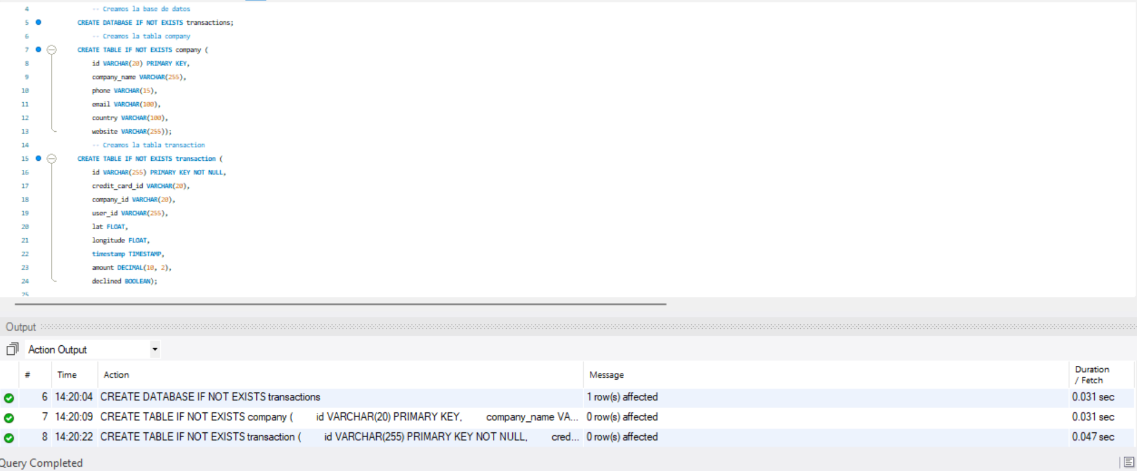
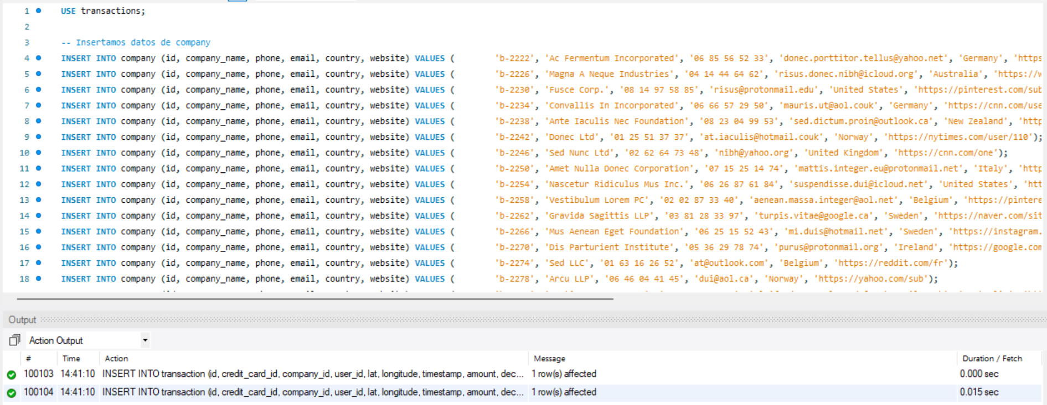
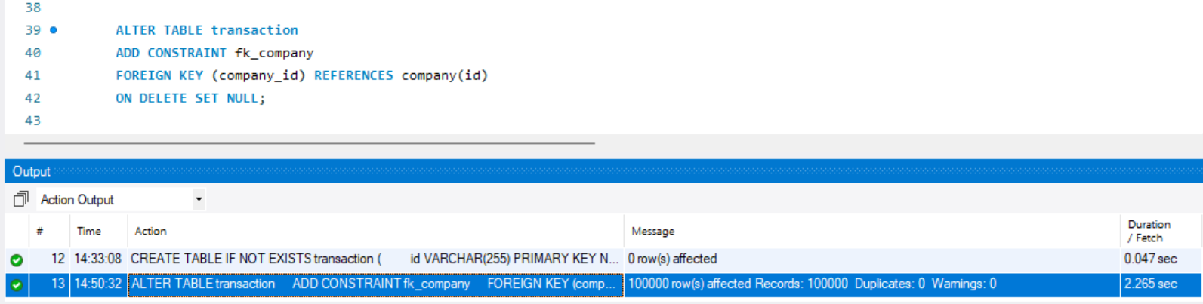
- I am creating a MySQL database called “transactions” to store company information and financial transactions.
- I am defining tables, their attributes, primary keys, and foreign keys to establish relationships between “company” and “transaction”.

Diagram (Database -> Reverse Engineer):

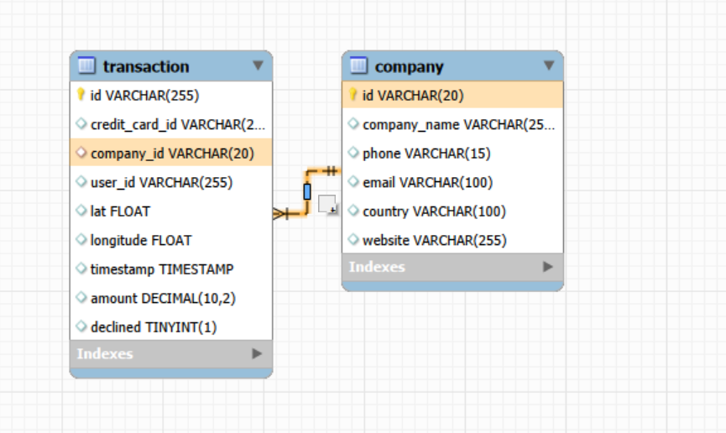

Ex.2 Queries
Using it JOIN you will make the following queries: * List of countries that are generating sales. * From how many countries are sales generated? * Identify the company with the highest average sales.
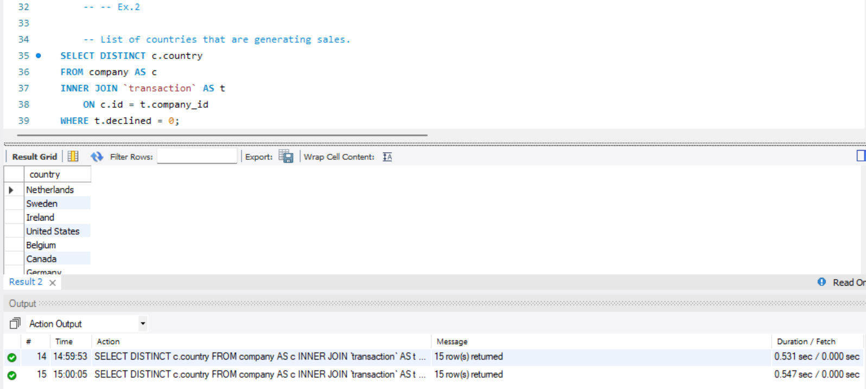
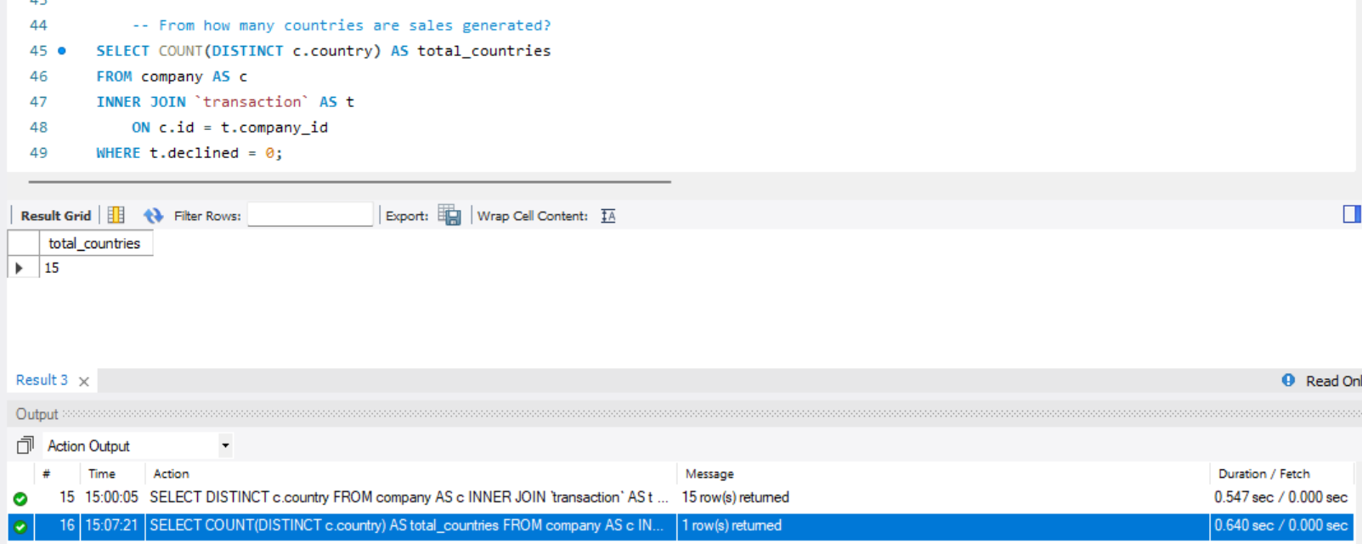
- We got total of 15 distinct countries
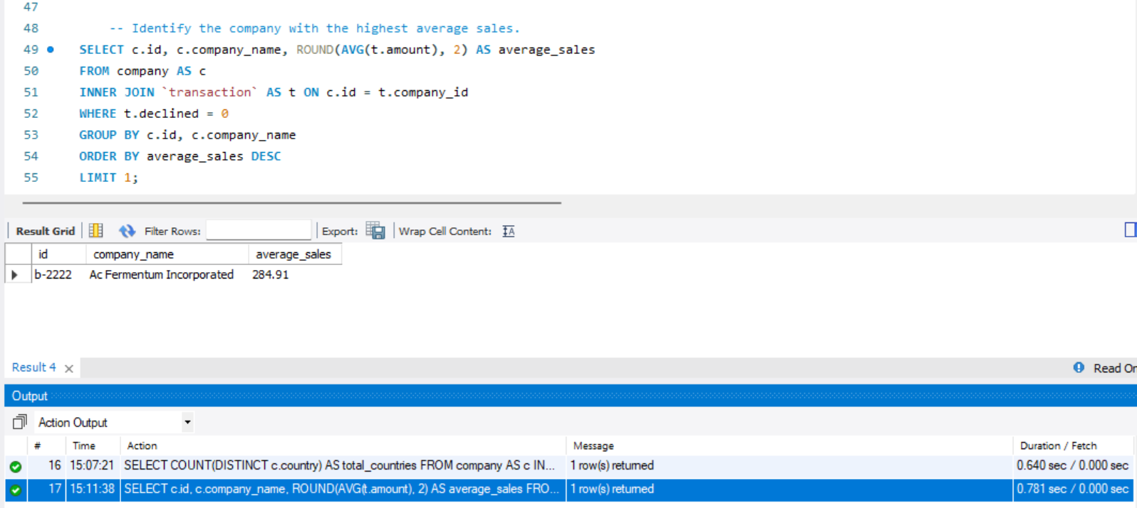
- The company’s highest average sale is 284.91

Ex.3 Subqueries
Using only subqueries (without using JOIN): * It shows all transactions made by companies in Germany. * Lists companies that have made transactions for an amount greater than the average of all transactions. * They will eliminate from the system companies that do not have registered transactions, provide a list of these companies.
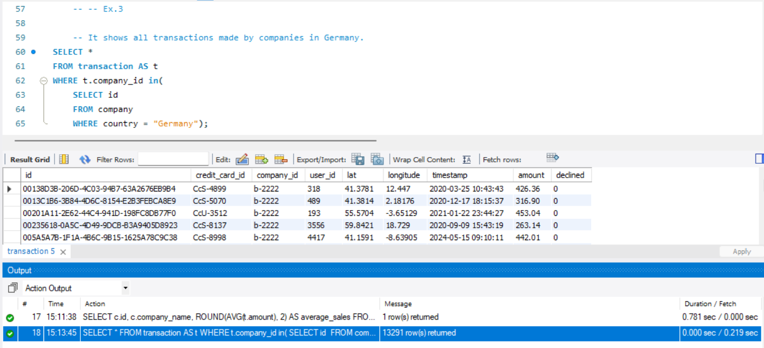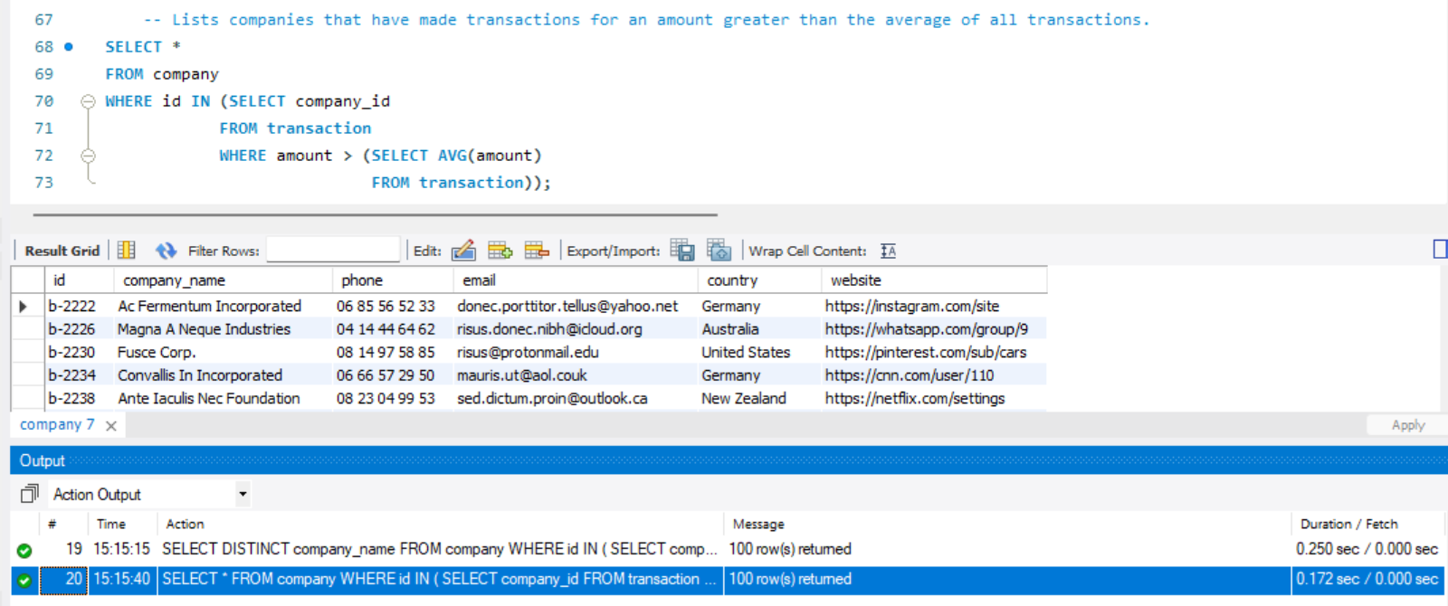
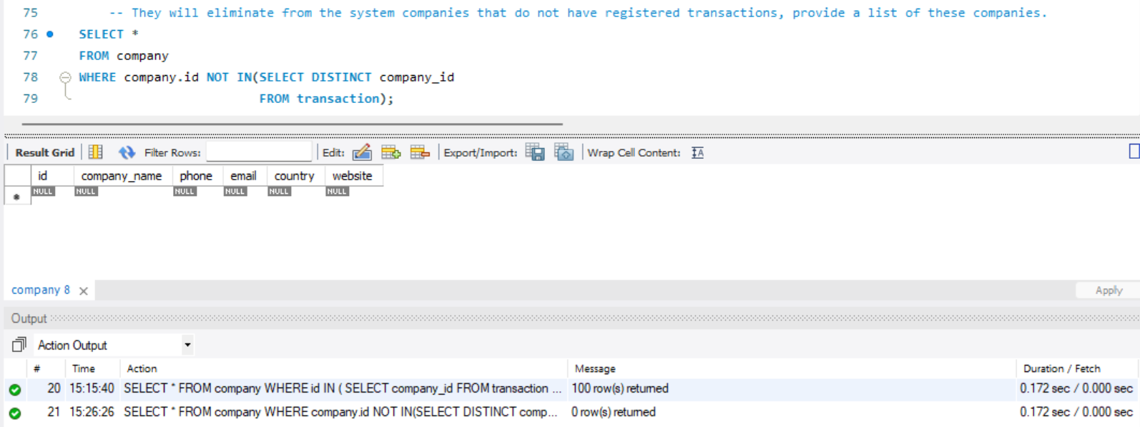
- There are 100 companies in total. All of them appear in the second query because each company has at least one transaction above the average value.
- All companies in the database have made at least one transaction. That is why the third query returns no results.

Ex.4 Create table credit_card
Your task is to design and create a table called "credit_card" that stores crucial details about credit cards. The new table must be able to uniquely identify each card and establish an appropriate relationship with the other two tables ("transaction" and "company"). After creating the table, you will need to enter the information in the document called "credit_input_data". Remember to show the diagram and provide a brief description of it.
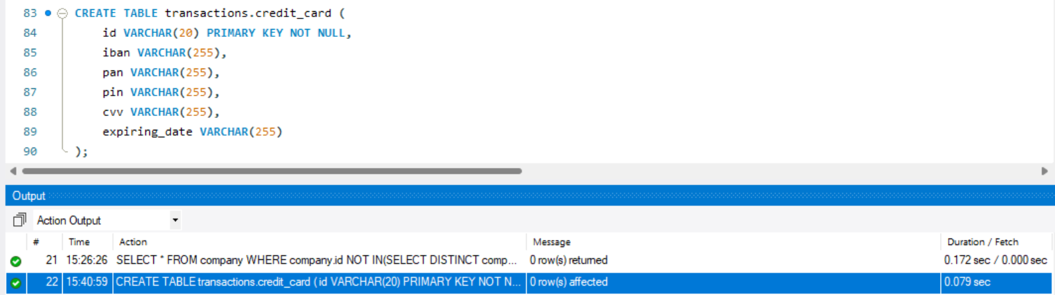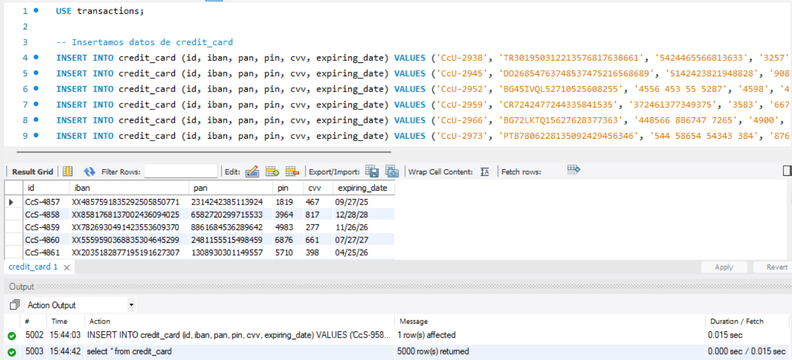
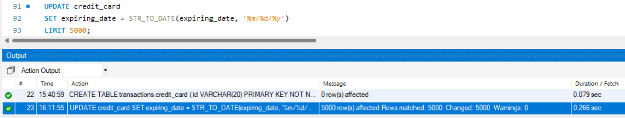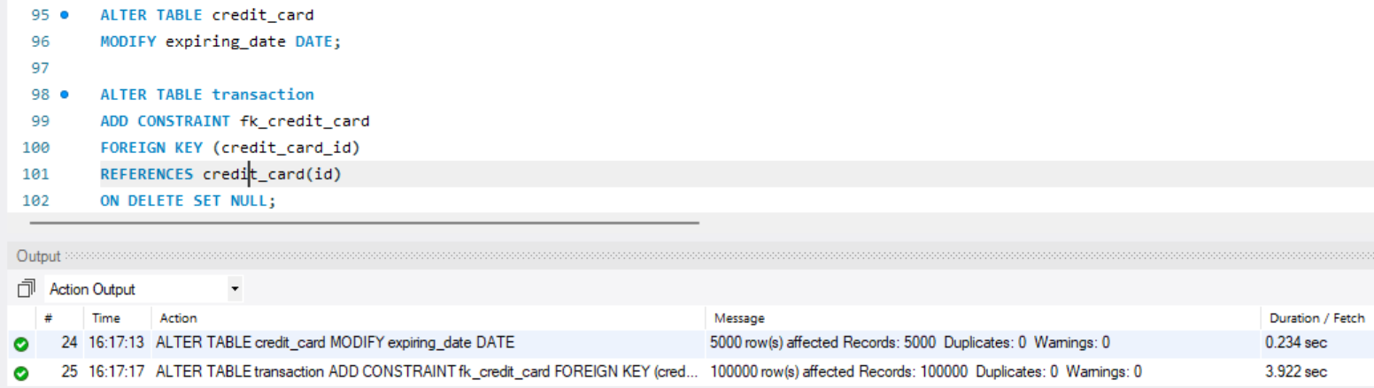
Diagram:
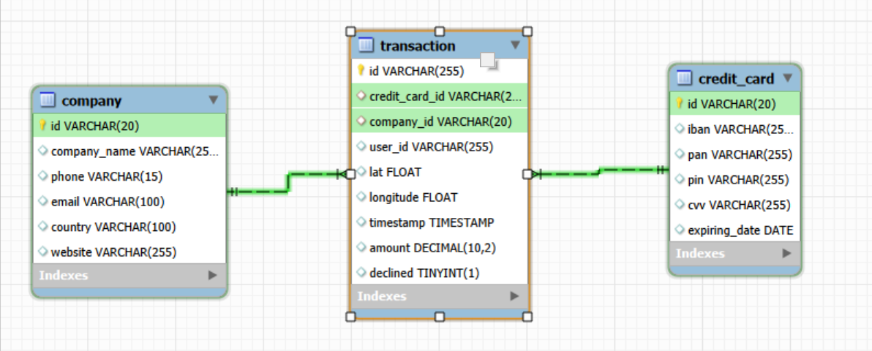

Ex.5

The Human Resources department has identified an error in the account number associated with the credit card with ID CcU-2938. The information that should be displayed for this record is: TR323456312213576817699999. Remember to show that the change was made.

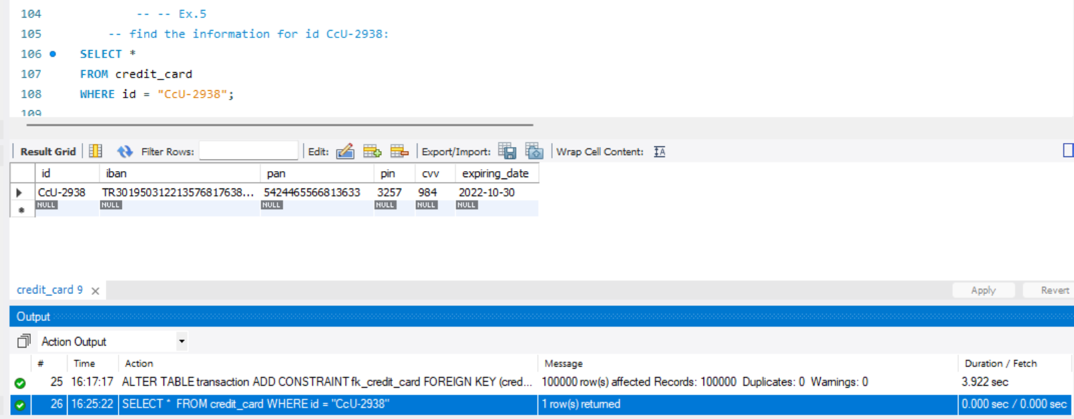

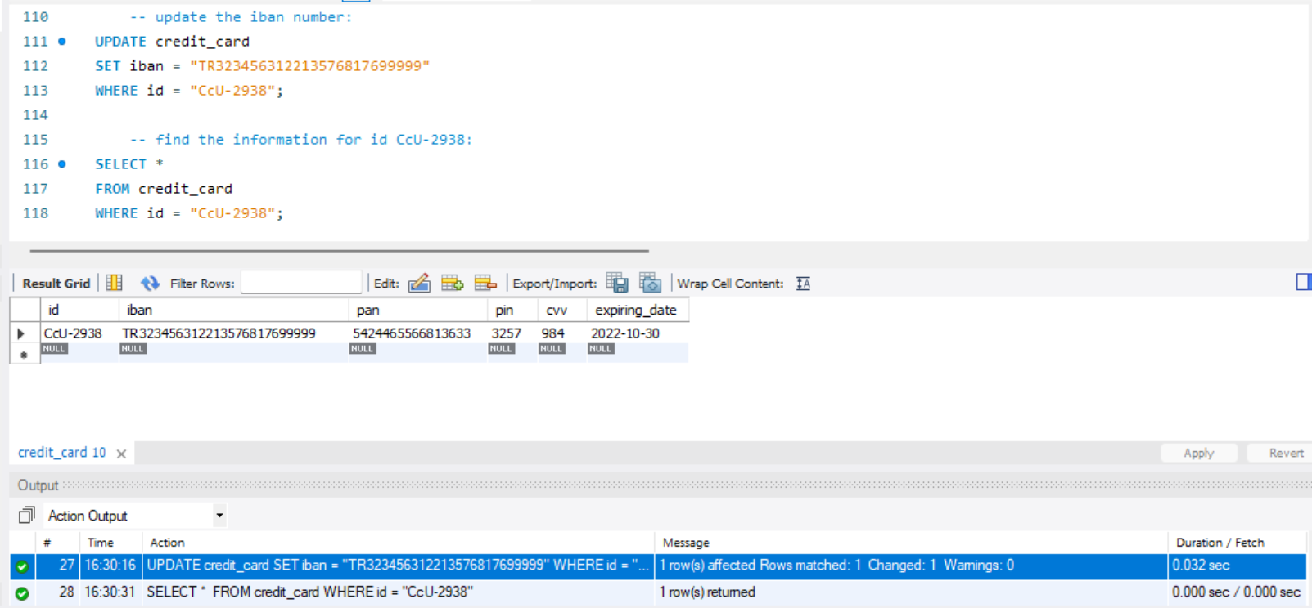

Ex.6

In the "transaction" table, enter a new transaction with the following information:

Id 108B1D1D-5B23-A76C-55EF-C568E49A99DD credit_card_id CcU-9999 company_id b-9999 user_id 9999 lat 829.999 longitude -117.999 amount 111.11 declined 0
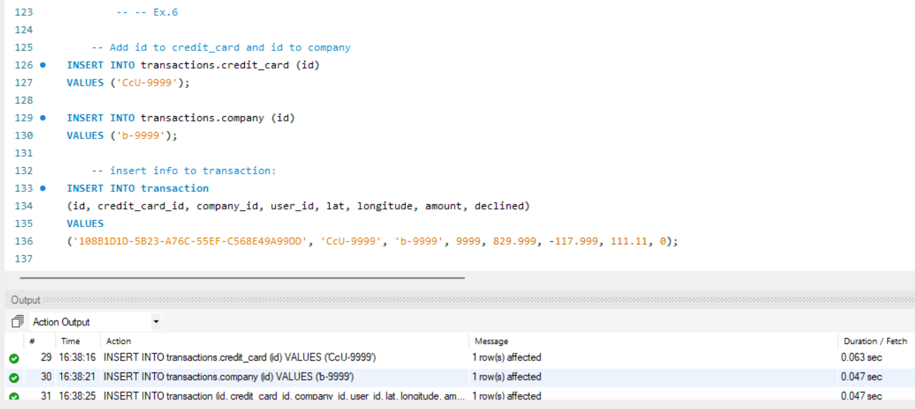

Ex.7

Human resources has asked you to delete the "pan" column from the credit_card table. Remember to show the change made.
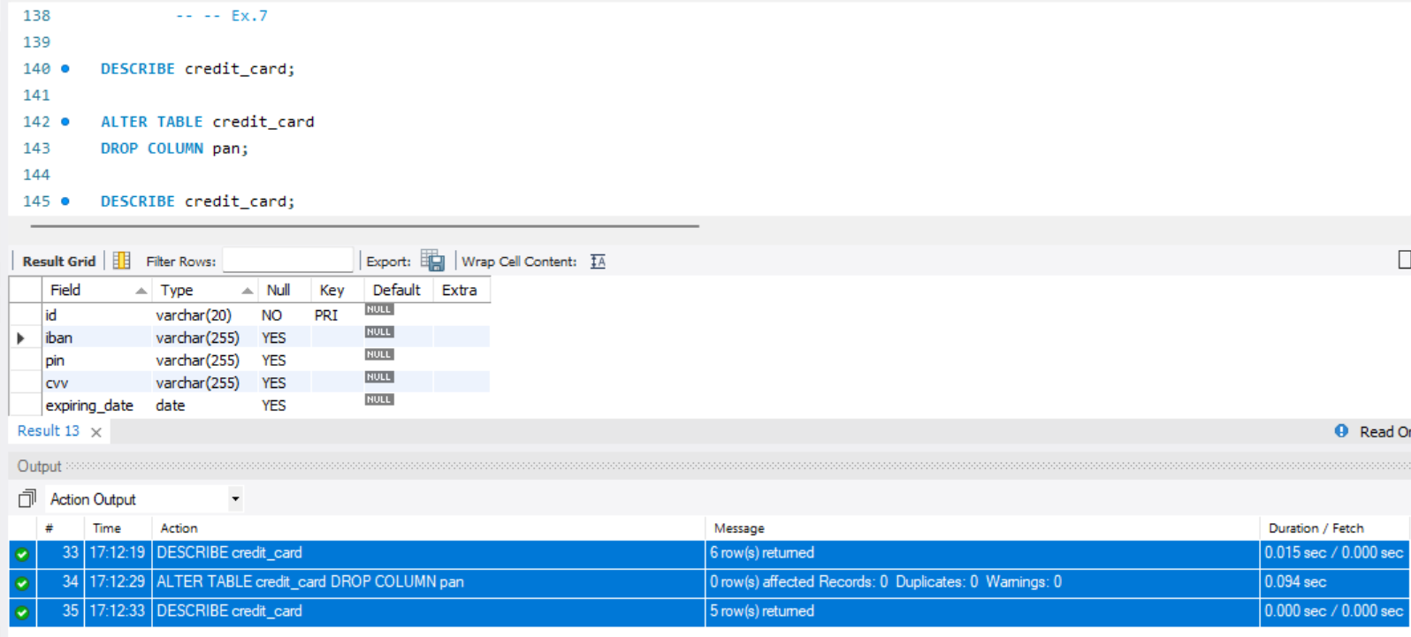

Ex.8

Download the CSV files that you will find in the resources section :

american_users.csv

european_users.csv

companies.csv

credit_cards.csv

transactions.csv

Study them and design a database with a star schema that contains at least 4 tables from which you can perform the following queries:
We will use the products.csv table later.

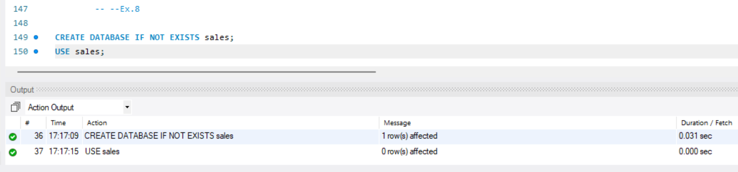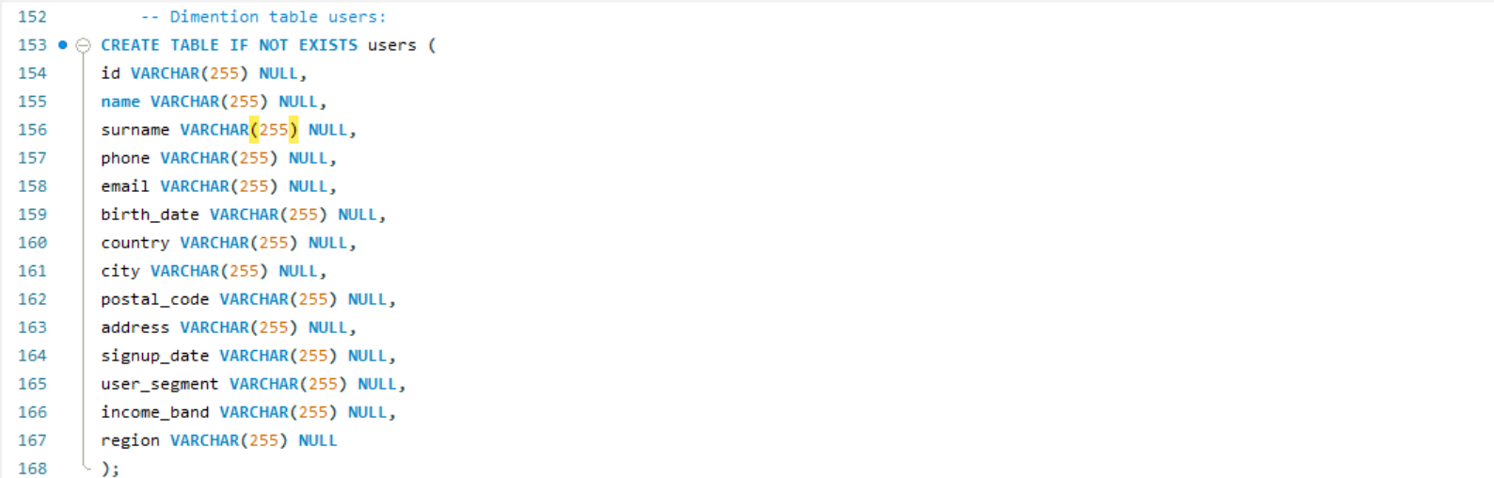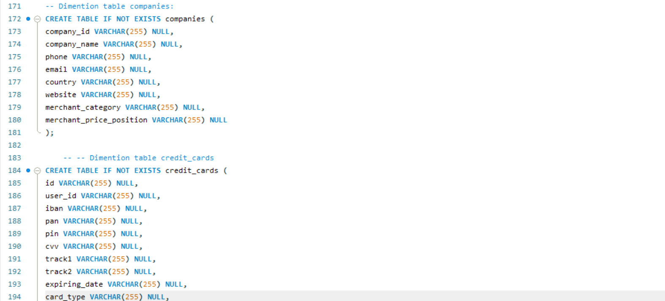

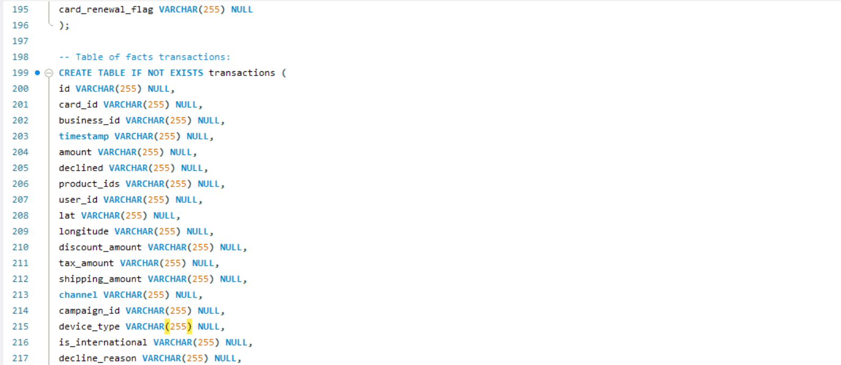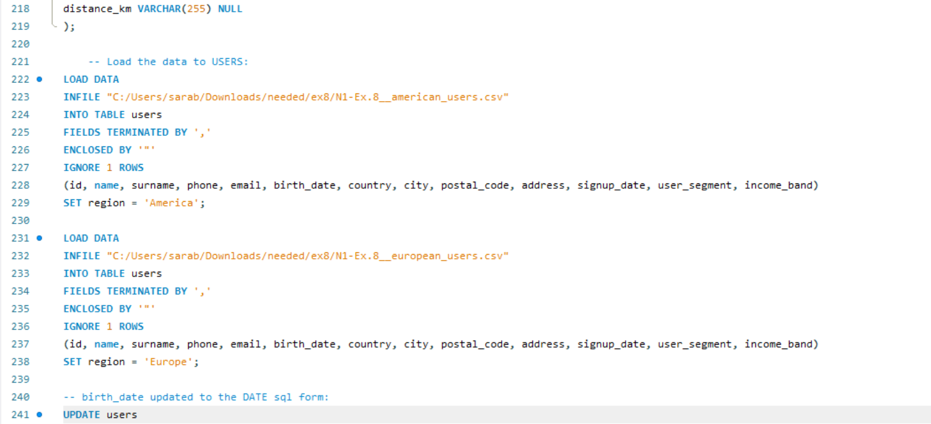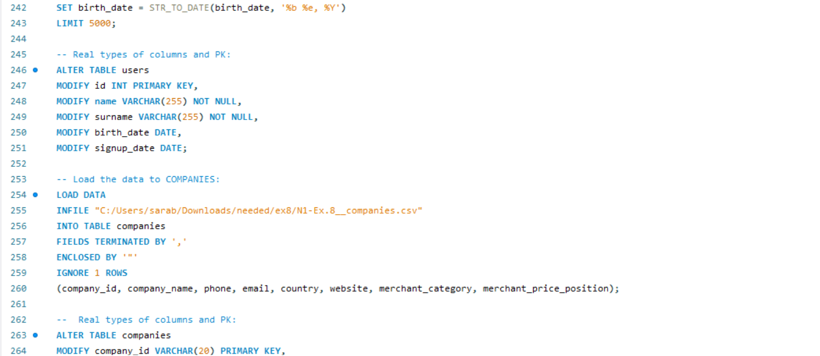
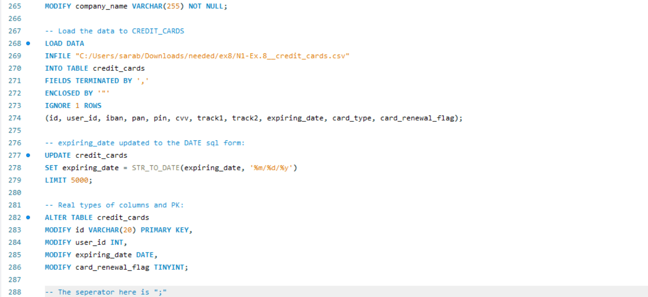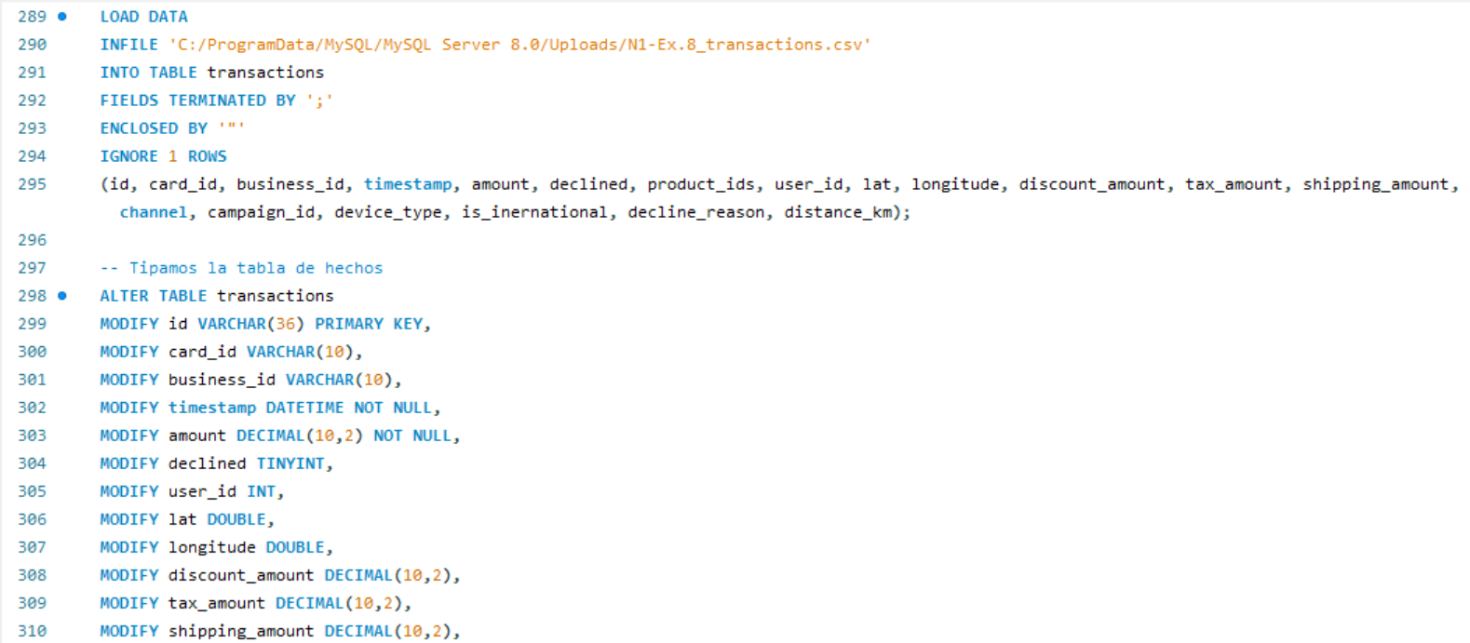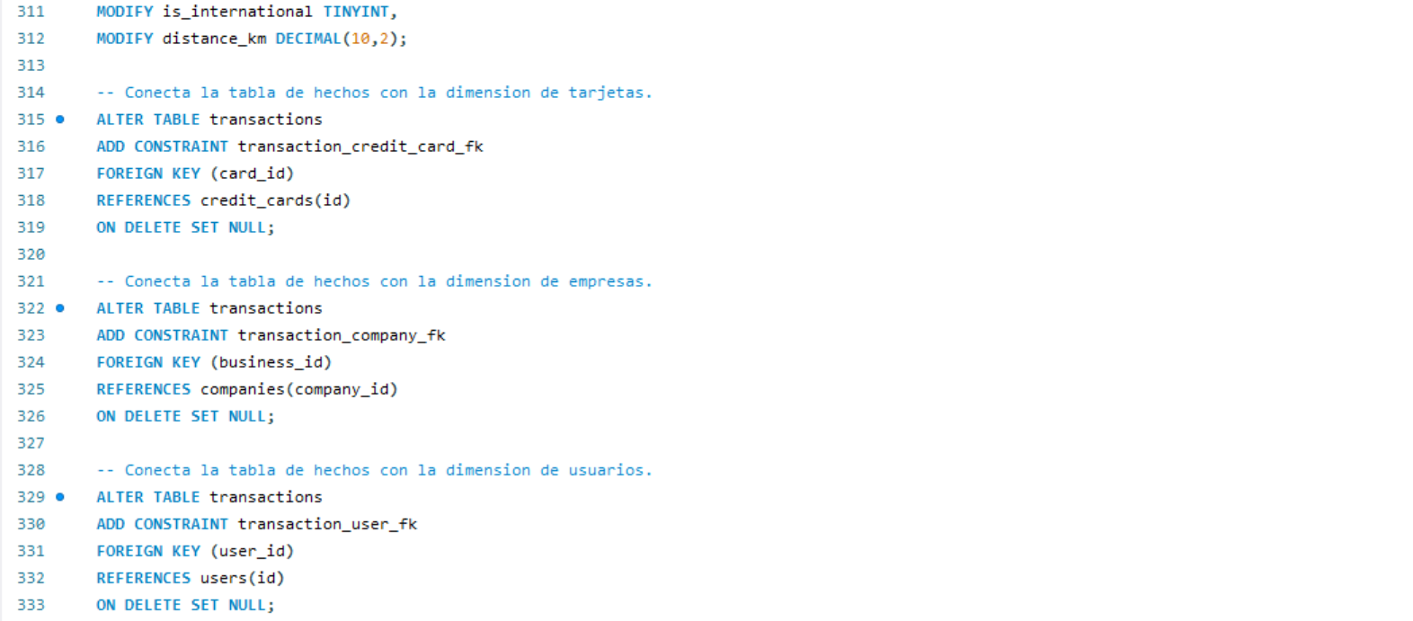

Proof of execution:
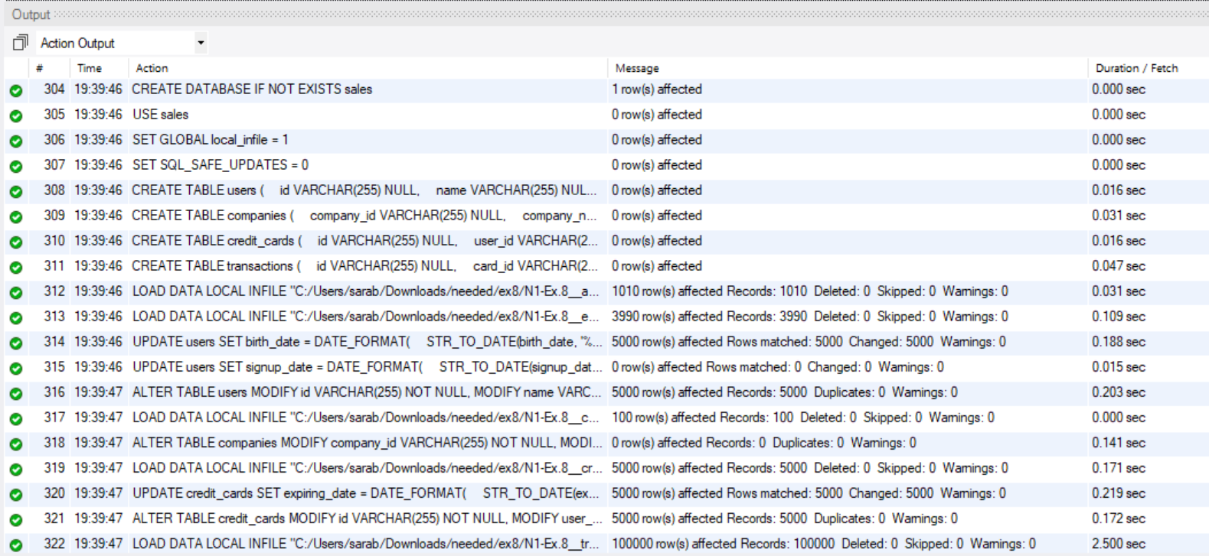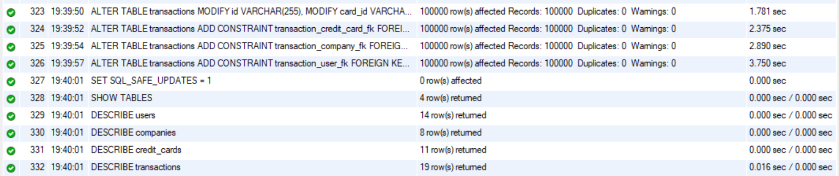
Diagram:
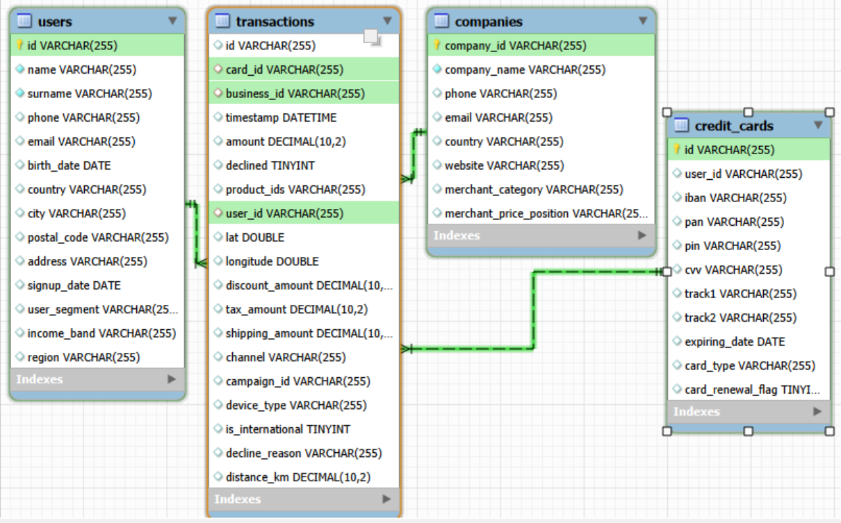

Ex.9
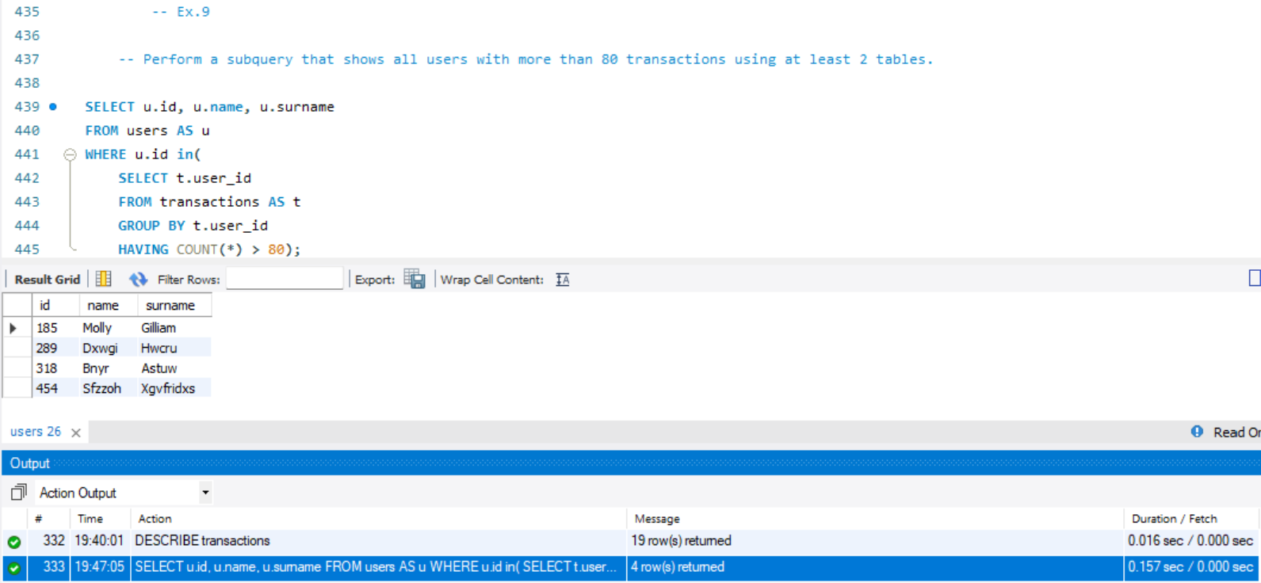

Ex.10
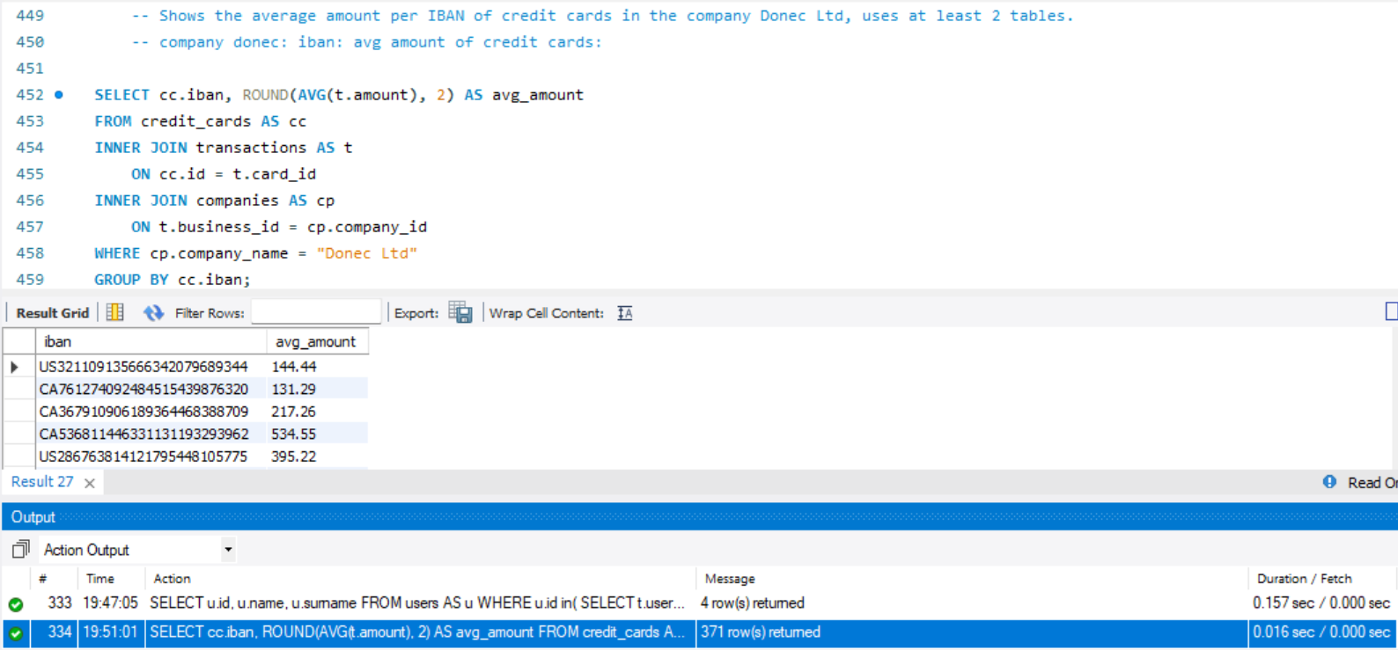

Nivel 2

Ex.1

Identifies the five days that generated the highest amount of revenue for your business from sales. It shows the date of each transaction along with the total sales.
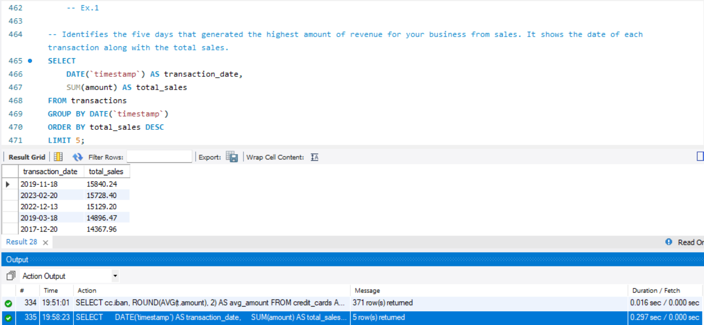

Ex.2

It presents the name, telephone number, country, date and amount of those companies that carried out transactions with a value between 350 and 400 euros and on one of these dates: April 29, 2015, July 20, 2018 and March 13, 2024. Sort the results from highest to lowest amount.
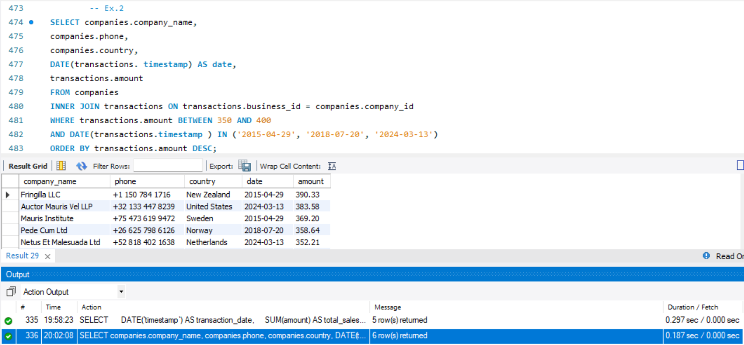

Ex.3

We need to optimize the allocation of resources and it will depend on the operational capacity required, so they ask you for information on the number of transactions that companies carry out, but the human resources department is demanding and wants a list of companies where you specify whether they have equal to or more than 400 transactions or less.
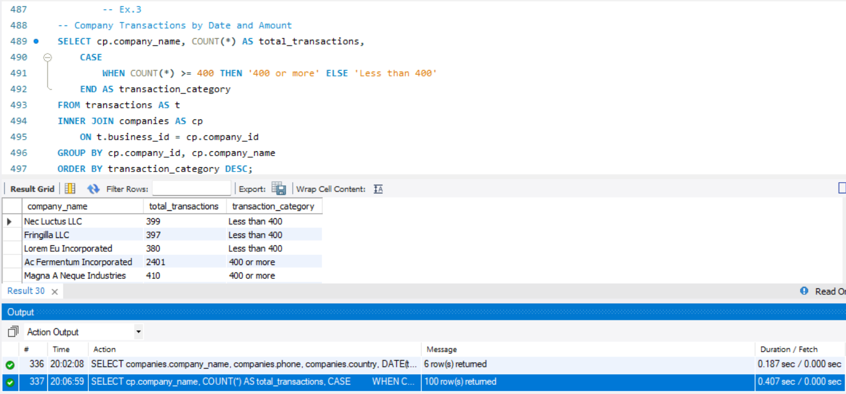

Ex.4

Remove from the transaction table the record with ID 000447FE-B650-4DCF-85DE-C7ED0EE1CAAD from the database.
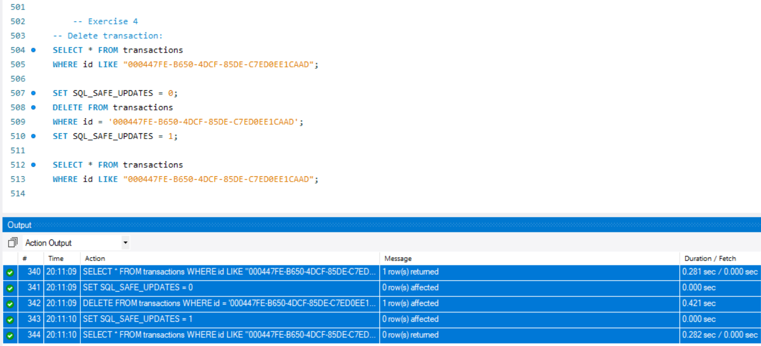

Ex.5

The marketing department wants to have access to specific information to perform effective analysis and strategies. It has been requested to create a view that provides key details about the companies and their transactions. You will need to create a view called VistaMarketing that contains the following information: Company name. Contact phone number. Country of residence. Average purchase made by each company. Present the view created, ordering the data from highest to lowest average purchase. 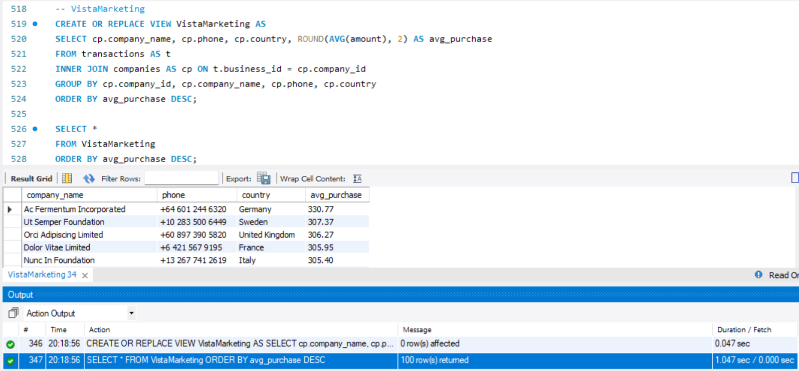

Nivel 3

Ex.1

Create a new table that reflects the status of credit cards based on whether the last three transactions have been declined then it is inactive, if at least one is not declined then it is active. Based on this table answer:

👉 How many cards are active? 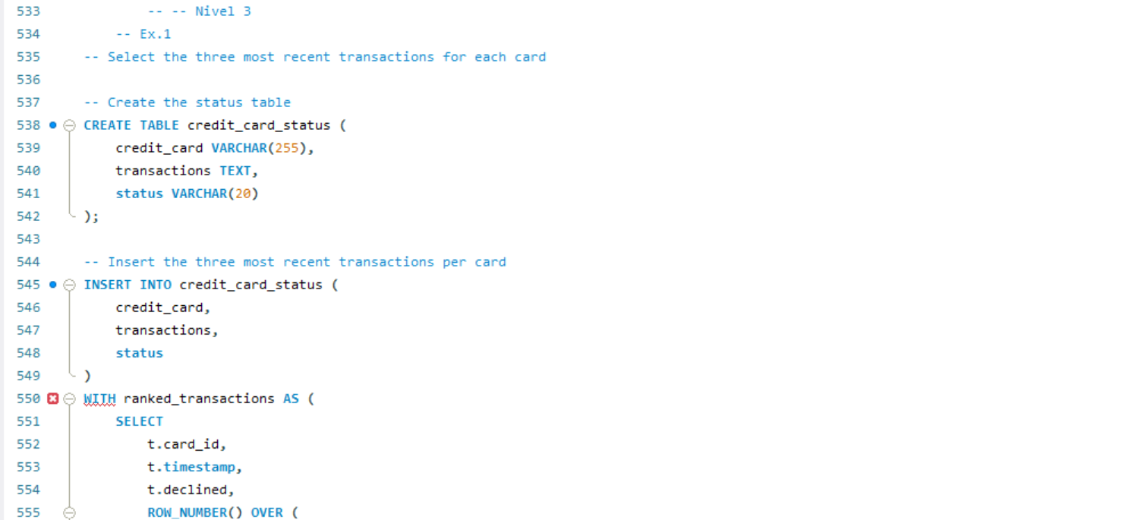 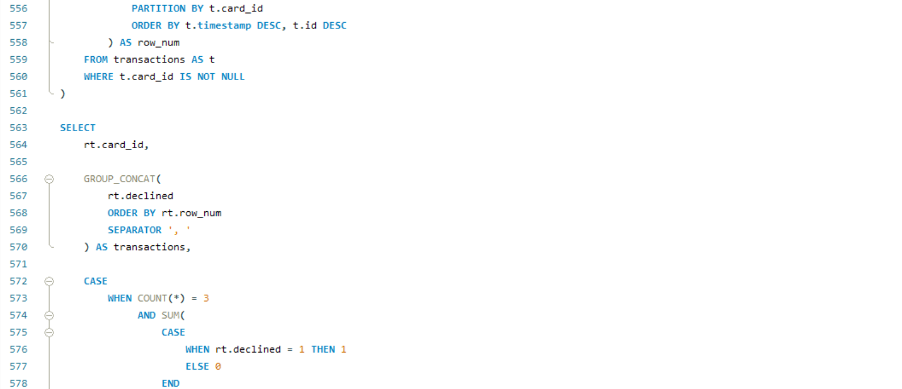 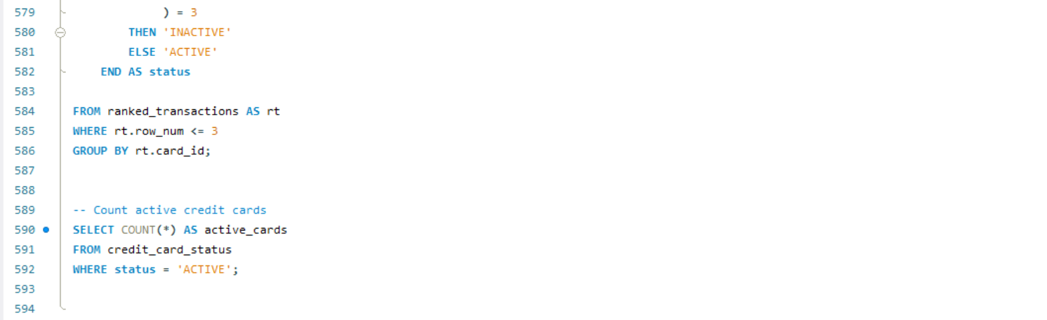

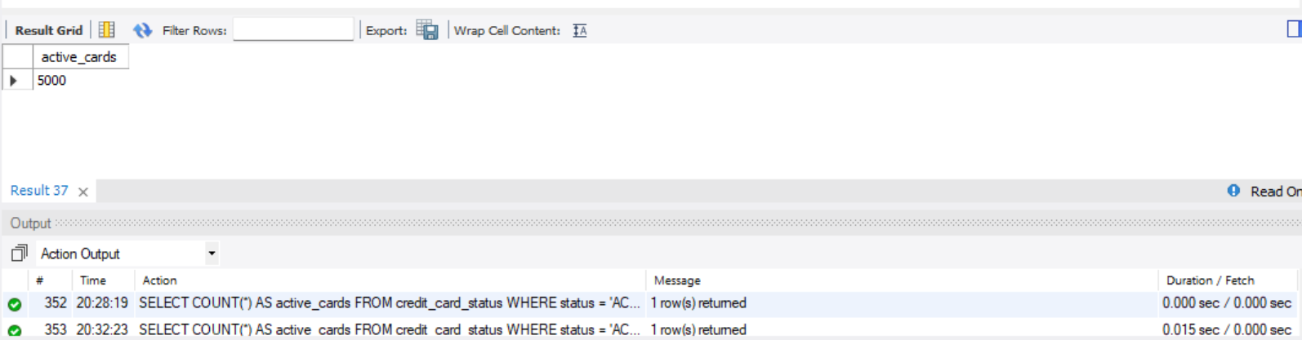
- All 5000 cards are “active”. There are no “inactive” cards.

Ex.2

Create a table with which we can join the data from the products.csv file with the database created (since until now we could not do it), taking into account that from transaction you have product_ids. Generate the following query:

👉 We need to know the number of times each product has been sold. 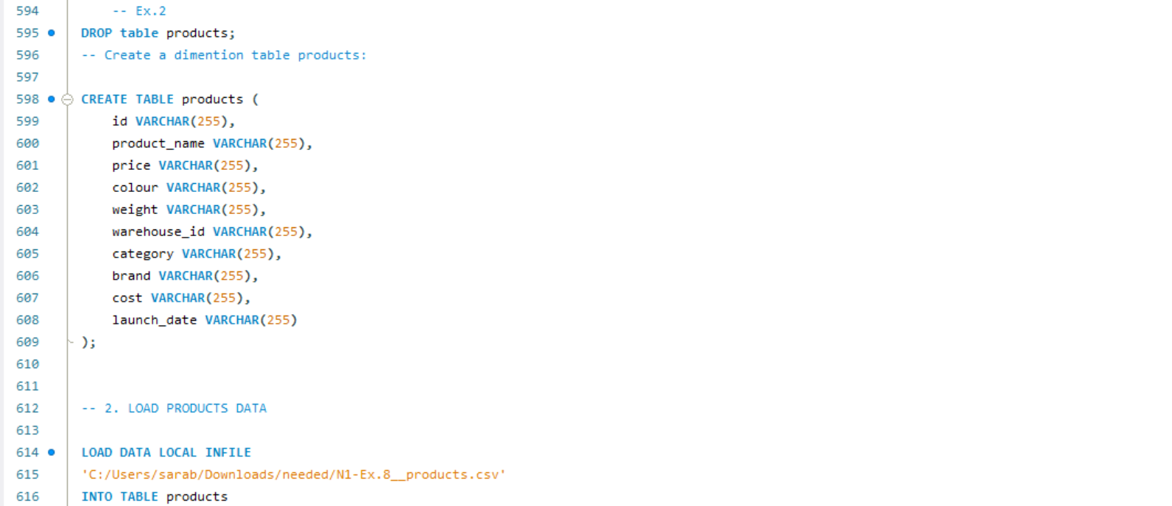 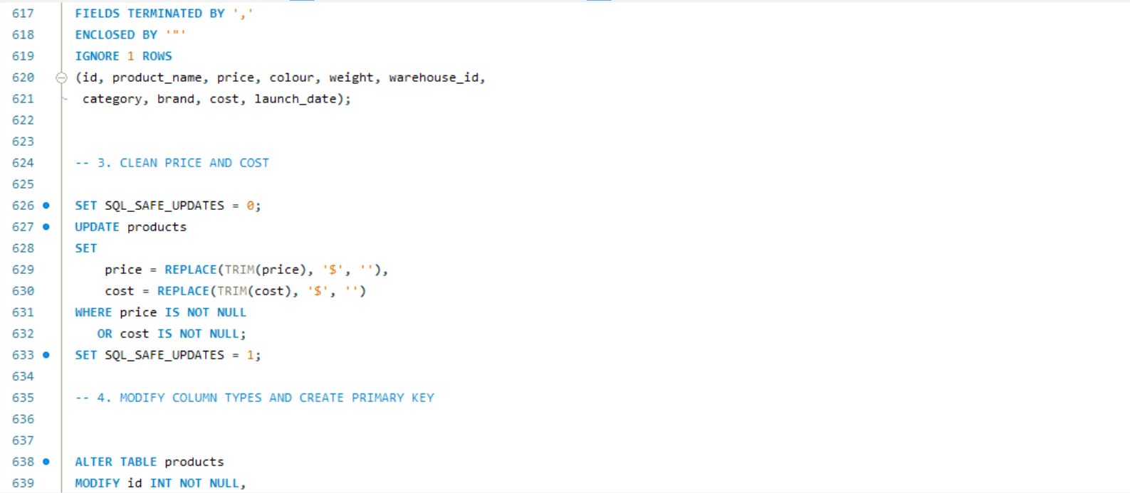
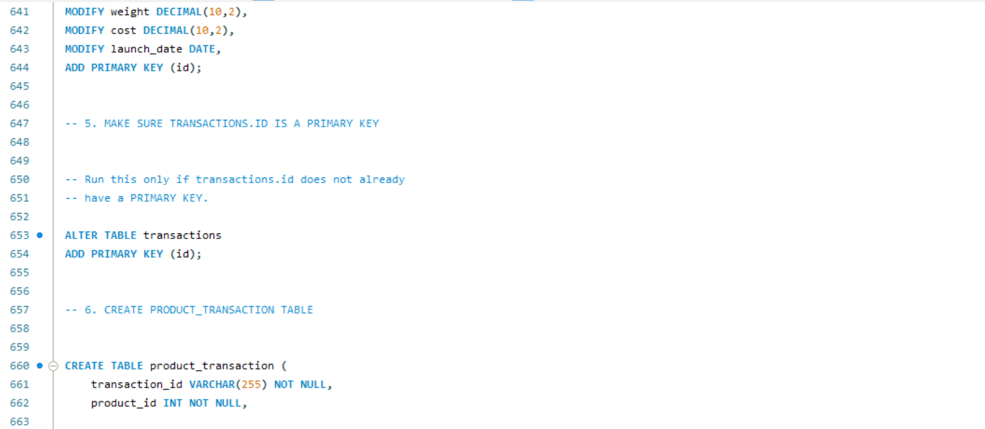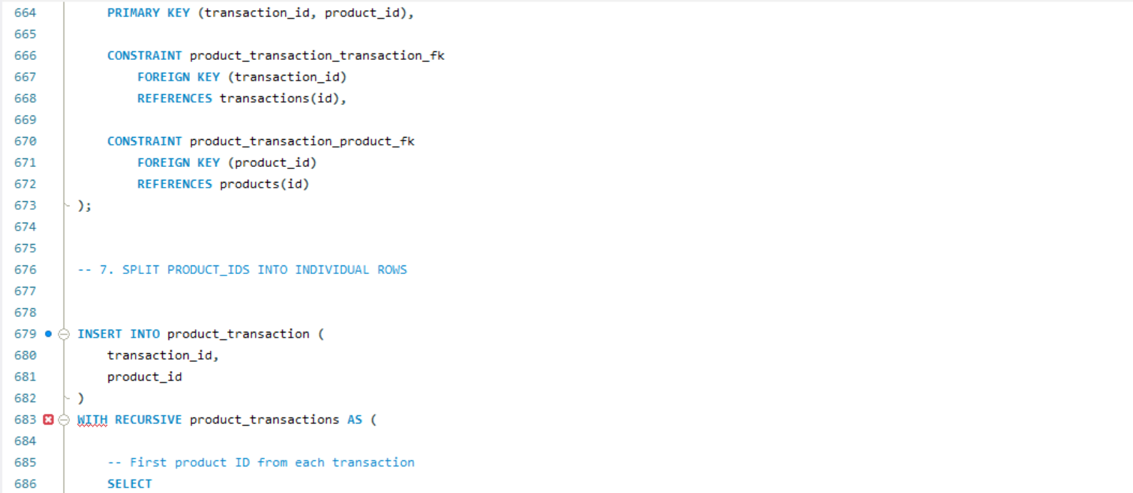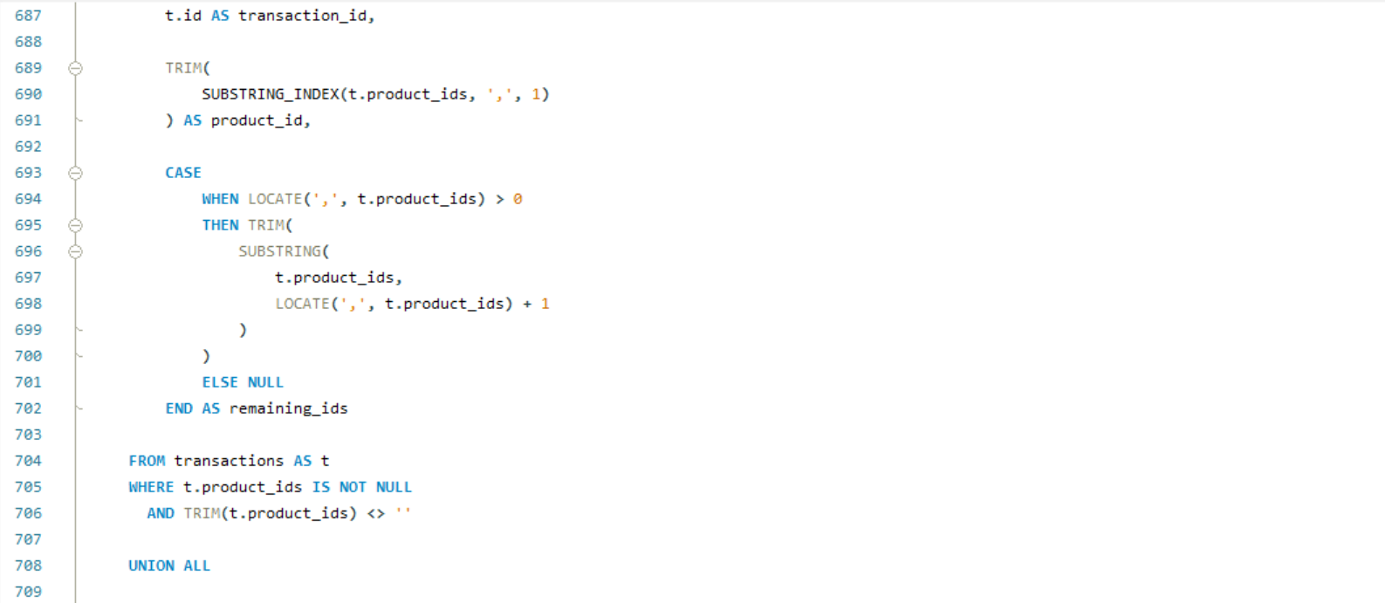
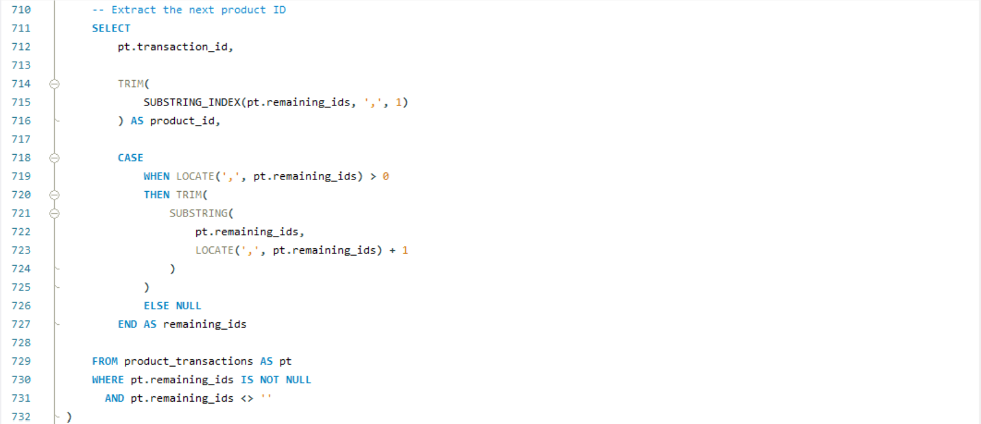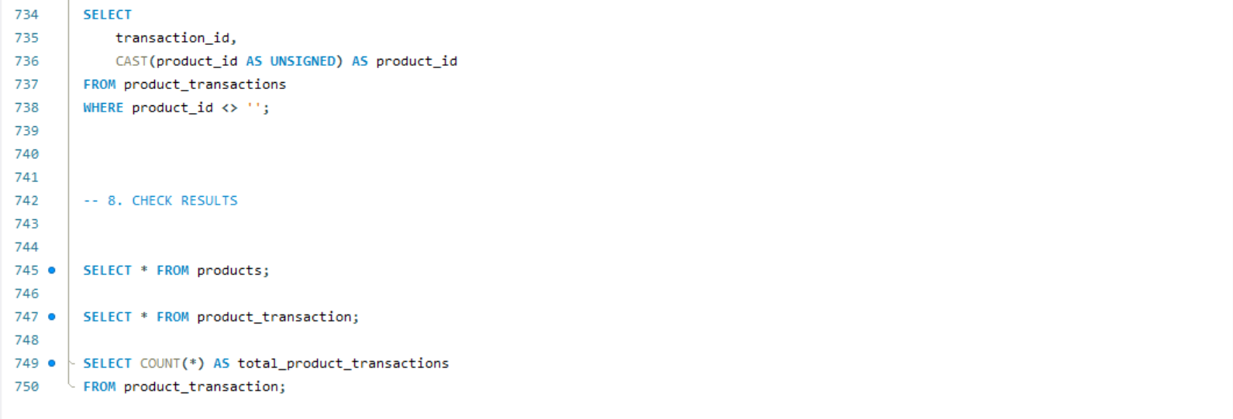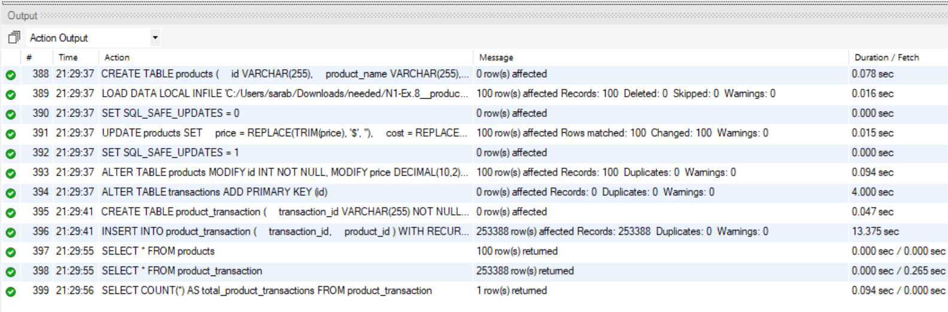
Diagram: 

